**IOT PROJECT**

**Flood Monitoring and Early Warning System**

TEAM MEMBERS:

AKASH R (210621106004)

ANTONY STYRIS R (210621106005)

DAVINS RANITH J (210621106014)

SRIRAM R (210621106049)

SURIYA K (210621106052)

**IOT_PHASE 5**

**INTRODUCTION**

Objective:

The objective of this mini project is to develop a Flood Monitoring and Early Warning System that can help communities and authorities detect and respond to flood events in a timely and efficient manner. This system will utilize sensor technology, data analysis, and communication channels to provide early warnings to at-risk areas.

Components and Implementation:

1. Sensor Network:

- Deploy a network of water level sensors at strategic locations in flood-prone areas.

- These sensors will continuously measure water levels and transmit data in real-time to a central server.

2. Data Collection and Analysis:

- Data collected from the sensors will be stored and processed in a central server.

- Utilize algorithms to analyze the data and identify potential flood conditions based on predefined thresholds.

3. Early Warning System:

- Develop an early warning system that triggers alerts when the sensor data indicates an impending flood.

- Alerts can be in the form of SMS, email, or mobile app notifications to residents and authorities.

4. Communication Infrastructure:

- Establish reliable communication channels between the sensor network, central server, and end-users.

- Use cellular networks or satellite communication to ensure data transmission even in remote areas.

5. Geographic Information System (GIS) Integration:

- Incorporate GIS data to map flood-prone areas, evacuation routes, and shelters.

- Display real-time flood information on a GIS-based dashboard.

6. User Interface:

- Create a user-friendly interface, such as a mobile app or web portal, for residents to receive alerts and access flood information.

7. Community Engagement:

- Educate and engage local communities on how to use the system and respond to flood warnings.

- Conduct outreach programs to raise awareness about flood preparedness.

8. Testing and Calibration:

- Regularly test and calibrate the sensors to ensure accurate data collection.

- Conduct drills and simulations to test the effectiveness of the warning system.

9. Maintenance and Upkeep:

- Establish a maintenance schedule for sensors and communication equipment.

- Ensure the system's reliability and durability in extreme weather conditions.

Benefits:

- Timely flood warnings can save lives and reduce property damage.

- Improved preparedness and response capabilities for both residents and authorities.

- Enhanced data collection for flood monitoring and research.

- Increased resilience to climate change-induced flooding.

**INOVATION:**

Components:

1. IoT Sensors:

Implement a network of IoT sensors strategically placed in flood-prone areas to monitor water levels, rainfall, and soil moisture in real-time.

1. Data Analytics Platform:

Create a robust analytics platform that processes data from sensors, utilizing machine learning algorithms to predict potential flood risks based on historical data and current weather patterns.

1. Mobile App:

Develop a user-friendly mobile application to provide real-time updates and early warnings to residents. Include features like evacuation routes, emergency contacts, and safety guidelines.

1. Community Engagement:

Establish a community outreach program to educate residents about the system, encourage participation, and raise awareness about flood preparedness. Collect local knowledge to improve the system’s accuracy.

1. Integration with Emergency Services:

Collaborate with local emergency services to integrate the system with their response mechanisms. Ensure seamless communication and coordination during flood events.

1. Drone Technology:

Explore the use of drones equipped with cameras and sensors to survey and assess flood situations. Drones can provide live visuals, aiding in decision-making for emergency responders.

1. Public-Private Partnerships:

Form partnerships with private companies, local businesses, and NGOs to secure funding, technical expertise, and community support for the project.

1. Localized Weather Stations:

Install weather stations in key locations to enhance the accuracy of the early warning system by capturing micro-climate variations that may contribute to flooding.

1. Education and Training:

Conduct workshops and training sessions for community members, local authorities, and emergency responders to ensure efficient use of the system and appropriate responses during flood events.

1. Scalability and Sustainability:

Design the system with scalability in mind, allowing for easy expansion to cover larger areas. Implement sustainable practices to ensure the long-term viability of the project.

By combining advanced technology, community engagement, and strategic partnerships, AquaGuard aims to create a comprehensive flood monitoring and early warning system that not only alerts residents but also empowers communities to proactively respond to potential flood risks.

**BUILDING UP IOT FLOOD MONITORING AND EARLY WARNING SYSTEM-DEPLOY IOT SENSOR IN FLOOD PRONE AREAS:**

1. Setup Hardware:

- Connect your water level sensor to your IoT device (e.g., Raspberry Pi or Arduino) and ensure that it’s properly calibrated and collecting data.

2. Install Required Libraries:

- Install any necessary libraries for your hardware and communication protocols. For example, you might need libraries for working with sensors (e.g., RPi.GPIO or Adafruit CircuitPython) and communication protocols (e.g., MQTT for IoT communication).

3. Collect Data:

- Read the water level data from the sensor at regular intervals.

4. Format the Data:

- Prepare the collected data in a format suitable for transmission to the Earthly warning platform. This format may vary depending on the platform’s requirements.

5. Send Data to Earthly Warning Platform:

- Use the appropriate protocol and APIs to transmit the data to the Earthly warning platform. This could be through HTTP, MQTT, or other methods depending on the platform’s supported protocols.

6. Handle Errors and Exceptions:

- Implement error handling to deal with issues like network connectivity problems or platform API errors.

python

Import time

Import requests # For HTTP communication with the platform

Import your_sensor_library # Import the library for your water level sensor

# Configuration for your sensor and platform

Sensor_pin = 17

Earthly_platform_url = <https://earthly-warning-platform-api-url.com>

Api_key = “your_api_key”

# Initialize the sensor (replace with your specific sensor code)

Sensor = your_sensor_library.setup(sensor_pin)

While True:

# Read water level data from the sensor

Water_level = sensor.read_data()

# Prepare data in the desired format

Data_to_send = {

“water_level”: water_level,

“timestamp”: time.time(),

}

Try:

# Send data to Earthly Warning Platform (replace with appropriate API call)

Response = requests.post(

F”{earthly_platform_url}/send_data”,

Json=data_to_send,

Headers={“Authorization”: f”Bearer {api_key}”}

)

If response.status_code == 200:

Print(“Data sent successfully.”)

Else:

Print(f”Error: {response.status_code} – {response.text}”)

Except Exception as e:

Print(f”Error: {str€}”)

Time.sleep(60) # Adjust the interval as needed

DEVELOPING IOT SENSOR IN FLOOD -PRONE AREAS TO MEASURE WATER LEVELS:

1. Select IoT Sensors:

- Choose appropriate water level sensors that are suitable for the environmental conditions in flood-prone areas. These sensors should be designed to withstand exposure to water and provide accurate measurements.

2. Hardware Setup:

- Set up the IoT sensors in the selected flood-prone areas. Ensure they are securely mounted to withstand flooding and other environmental factors. Power the sensors using a reliable source, such as solar panels and batteries.

3. Connect to IoT Devices:

- Connect the water level sensors to IoT devices like Raspberry Pi, Arduino, or specialized IoT gateways. These devices will collect data from the sensors.

4. Install Communication Modules:

- Equip the IoT devices with communication modules, such as cellular modems, Wi-Fi, or LoRa, to transmit data to a central server or platform. Ensure that these devices have internet connectivity.

5. Data Collection and Processing:

- Develop or configure software on the IoT devices to collect and process data from the water level sensors. This may involve calibration, data filtering, and formatting.

6. Data Transmission:

- Set up protocols (e.g., MQTT, HTTP) for transmitting data from the IoT devices to a central server or cloud platform. Implement security measures to protect data during transmission.

7. Central Data Platform:

- Create a central data platform or use an existing IoT platform to receive, store, and analyze the collected data. This platform should be capable of handling data from multiple sensors.

8. Data Visualization and Analysis:

- Develop a dashboard or interface for monitoring and analyzing the water level data in real-time. Implement algorithms for flood prediction and early warning systems.

9. Alerting System:

- Integrate alerting mechanisms into your platform to notify authorities and residents when water levels reach critical thresholds. Alerts can be sent via SMS, email, or other communication channels.

10. Maintenance and Monitoring:

- Regularly maintain and monitor the deployed IoT sensors to ensure they are functioning correctly. Replace batteries and sensors as needed.

11. Community Engagement:

- Engage with the local community and authorities to ensure they are aware of the monitoring system and understand how to respond to alerts.

12. Regulatory Compliance:

- Ensure compliance with any relevant regulations or permits for deploying sensors in flood-prone areas.

**DEVELOPING OF FLOOD MONITORING SYSTEM USING WEB DEVELOPMENT TECHNOLOGY:**

Creating a flood monitoring and early warning system is a complex project that involves various components, including data collection, analysis, and communication. Here are some key steps and considerations for such a project:

1. Data Collection:

- Implement a network of sensors to collect data on water levels, rainfall, weather conditions, and river flow.

- Use remote sensing technologies like satellites and radar to gather additional data.

- Ensure data accuracy and reliability through regular maintenance and calibration.

2. Data Analysis:

- Develop algorithms and models to analyze the collected data in real-time.

- Use historical data to identify trends and patterns that can help predict floods.

- Integrate meteorological and hydrological data to assess flood risk.

3. Early Warning System:

- Implement an early warning system that triggers alerts based on predetermined thresholds.

- Ensure that the system can send alerts to relevant authorities, emergency services, and the public through various communication channels (SMS, mobile apps, sirens, etc.).

4. Geospatial Information System (GIS):

- Utilize GIS to map flood-prone areas and create detailed flood risk maps.

- Combine GIS with real-time data to monitor and predict flood events accurately.

5. Community Engagement:

- Educate and engage local communities in understanding and responding to flood alerts.

- Provide guidelines for evacuation and safety measures.

6. Government and Stakeholder Collaboration:

- Collaborate with government agencies, NGOs, and local authorities to coordinate flood response efforts.

- Ensure the availability of resources and infrastructure for flood management.

7. Monitoring and Maintenance:

- Regularly monitor and maintain sensors and equipment to ensure they remain functional.

- Continuously update and improve the data analysis algorithms and early warning system.

8. Disaster Preparedness:

- Develop and implement disaster preparedness plans that include evacuation routes, shelters, and resource allocation.

9. Public Awareness:

- Conduct public awareness campaigns to educate the population about flood risks and the importance of early warning systems.

10. Regulatory Compliance:

- Ensure that the project complies with relevant environmental and data privacy regulations.

11. Scalability and Resilience:

- Design the system to be scalable, accommodating future expansion and technological advancements.

- Implement backup systems and redundant communication channels to ensure system reliability during adverse conditions.

12. Testing and Simulation:

- Conduct regular testing and simulations to evaluate the system’s effectiveness and response times.

13. Data Storage and Analysis:

- Establish robust data storage and backup systems to maintain historical data for analysis and research.

Remember that a successful flood monitoring and early warning project requires a multidisciplinary approach, involving experts in meteorology, hydrology, data science, and community outreach. Collaboration with relevant stakeholders and regular updates to the system are key to its long-term success.

**Web Code:**

**Import time**

Import machine

Import dht

# Define GPIO pins

TRIG_PIN = machine.Pin(2, machine.Pin.OUT)

ECHO_PIN = machine.Pin(3, machine.Pin.IN)

BUZZER_PIN = machine.Pin(4, machine.Pin.OUT)

DHT_PIN = machine.Pin(5)

LED_PIN = machine.Pin(6, machine.Pin.OUT)

Def distance_measurement():

# Trigger ultrasonic sensor

TRIG_PIN.on()

Time.sleep_us(10)

TRIG_PIN.off()

# Wait for echo to be HIGH (start time)

While not ECHO_PIN.value():

Pass

Pulse_start = time.ticks_us()

# Wait for echo to be LOW (end time)

While ECHO_PIN.value():

Pass

Pulse_end = time.ticks_us()

# Calculate distance

Pulse_duration = time.ticks_diff(pulse_end, pulse_start)

Distance = pulse_duration / 58 # Speed of sound (343 m/s) divided by 2

Return distance

Def read_dht_sensor():

D = dht.DHT22(DHT_PIN)

d.measure()

return d.temperature(), d.humidity()

buzz_start_time = None # To track when the buzzer started

while True:

dist = distance_measurement()

temp, humidity = read_dht_sensor()

# Check if the distance is less than a threshold (e.g., 50 cm)

If dist < 50:

# Turn on the buzzer and LED

BUZZER_PIN.on()

LED_PIN.on()

Status = “Flooding Detected”

Buzz_start_time = time.ticks_ms()

Elif buzz_start_time is not None and time.ticks_diff(time.ticks_ms(), buzz_start_time) >= 60000: # 1 minute

# Turn off the buzzer and LED after 1 minute

BUZZER_PIN.off()

LED_PIN.off()

Status = “No Flooding Detected”

Else:

Status = “No Flooding Detected”

Print(f”Distance: {dist:.2f} cm”)

Print(f”Temperature: {temp:.2f}°C, Humidity: {humidity:.2f}%”)

Print(“Status:”, status)

Time.sleep

**Stimulation output**

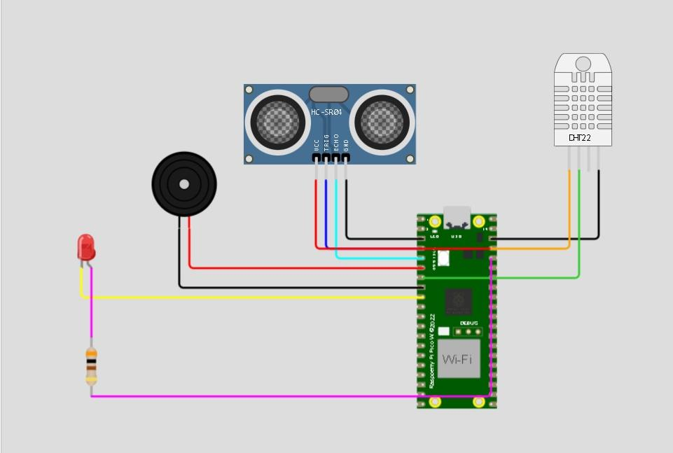

**Sample output:**

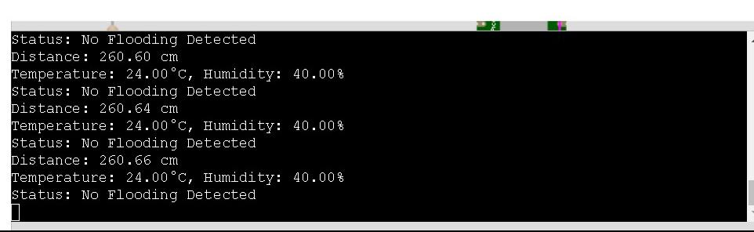

**CONCLUSION:**

The conclusion of a flood monitoring and early warning system would typically depend on the specific goals and outcomes of the system. However, some common conclusions could include:

1. Effectiveness: Assess the system's effectiveness in terms of early detection of flood events, accurate monitoring, and timely dissemination of warnings.

2. Impact: Evaluate the impact of the system on reducing flood-related damages, injuries, and loss of life.

3. Data Quality: Ensure that the data collected by the system is reliable and accurate, as this is critical for making informed decisions.

4. Public Awareness: Assess the level of public awareness and understanding of the warnings and evacuation procedures provided by the system.

5. Continuous Improvement: Highlight the need for ongoing system improvements and updates to adapt to changing conditions and emerging technologies.

6. Collaboration: Emphasize the importance of collaboration among relevant agencies and organizations to enhance the overall effectiveness of the system.